Final Project for GISC 1491
Fall 2015
GISC 1491 requires that you complete a final GIS project worth 15% of your final grade.
This project will include:
1. Developing a geographic question that can be analyzed by GIS.
2. Using ModelBuilder, create a Model to analyze your geographic question.
3. The model should include at least one parameter that must be set by the user.

Geographic Question:
Using GIS and ModelBuilder, create a Model that ascertains multiple buffer zones for volcanos in the United States that are most likely to erupt near cities with large populations (we are using 300,000 or over but the user may specify a different population amount). The intensity of an eruption could affect the distance of the buffer zones around a volcano. We will be utilizing different distances for the buffer zones, and that parameter may be set by the user as well. The volcanos used in the results of this Model are documented to have erupted at least ten times in recent human history but the user may specify different known eruption amounts.

Written Description: Volcanoes Model
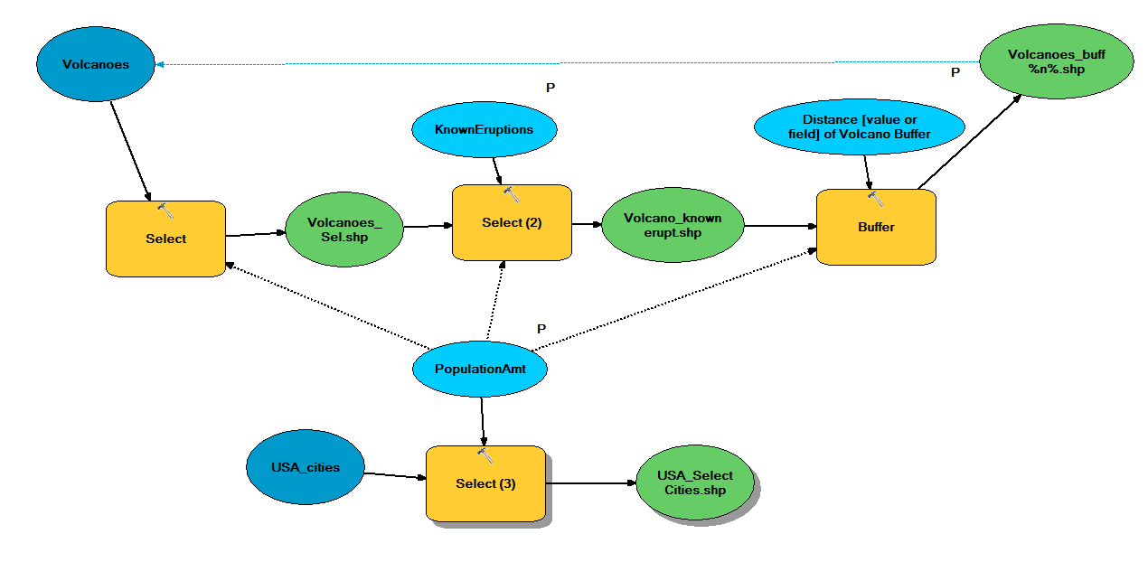

I selected all the locations by right clicking Volcanoes.shp file then to “Selection”→”Select All” (just for double checking purposes for the next step).

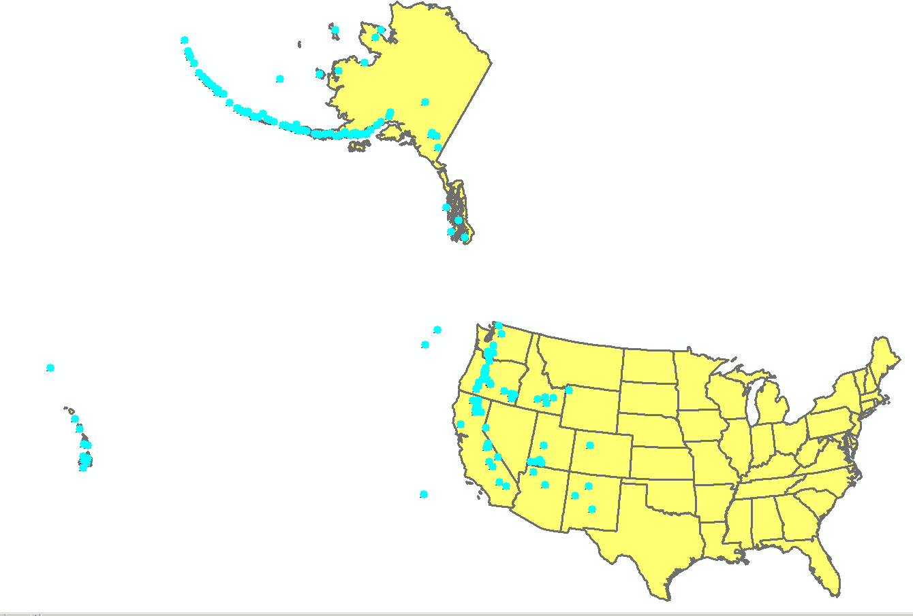

I used the Select Feature tool to select all the Volcanoes.shp file locations and got an output layer called Volcanoes_Sel.shp file, which I used as “intermediate” data to not show the layer itself on the map.
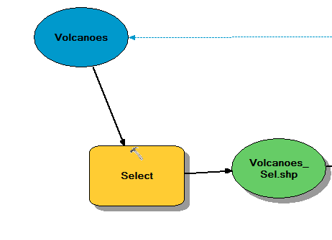
I used the Select Feature tool again to look for Volcanoes that were known to erupt in recent history using Volcano Sel.shp file.

I got an output layer called Volcano_known_erupt.shp file using Volcano Sel.shp file and KnownEruptions parameter.
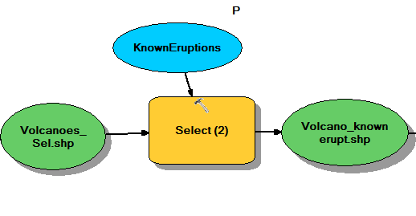

The First Parameter selected with default number of 10. Double-click the model in ArcCatalog to get this window. This parameter can be adjusted by the user.
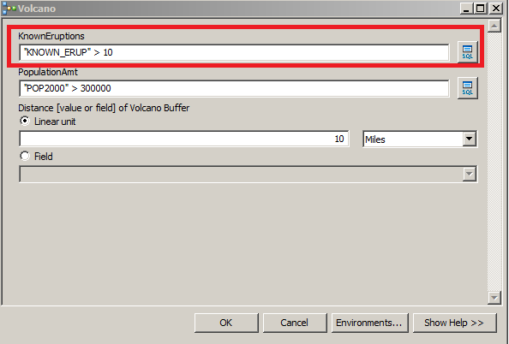

I used the Buffer tool for the Volcano_known_erupt.shp file to get the buffer distance for the volcanoes.

I got an output file called Volcano_buff_%n%.shp file, which I used as “intermediate” data to not show the layer itself.

Both the Volcano Sel.shp file and the Distance [value or field] of Volcano Buffer parameter were used to get the Volcano_buff_%n%.shp file.
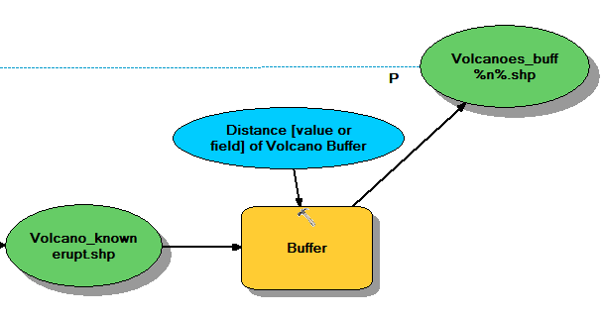

The Second parameter selected with default number of 10 Miles. Double-click the model in ArcCatalog to get this window. This parameter can be adjusted by the user.
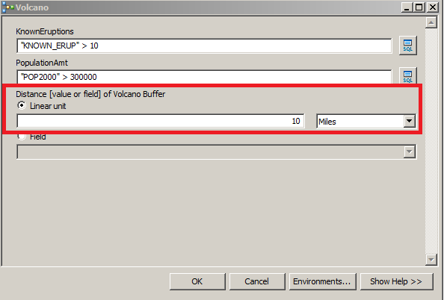

We make iterations for Volcanoes_buff%n%.shp to show a Buffer in a Buffer.

We go to Model →Model Properties→ Volcanoes_buff%n%.shp and go to General tab inside the model. We can now set the number of iterations, which is “4” see below.
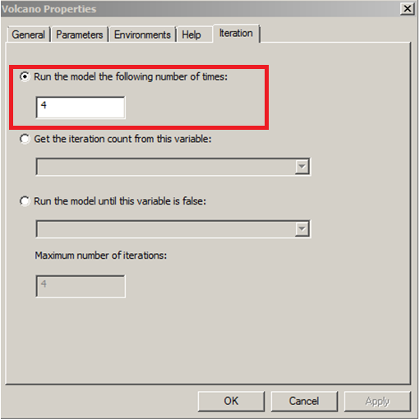

Inside General Tab→Feeback Variable of Volcanoes_buff%n%.shp we select and type “Output Feature Class.” (We are tying the process back to the beginning for the Feed back variable so we don’t overwrite the iterations and why we use the %n%).
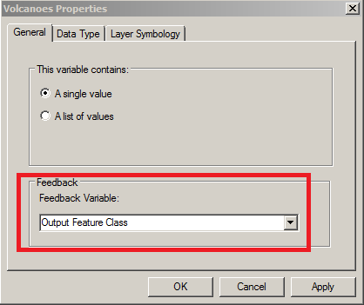
(After you press okay you go to a toolbox window called Output Feature Class and you will have to replace the ending output file name with %n% on the end of the Volcanoes_buff to say Volcanoes_buff %n% specifing the iterations).

Dashed blue lines are the “Feedback Variable” we just set up

We check this process by right clicking the Volcanoes.shp file from the beginning to see the “Feedback Variable.” (After we run the Model)
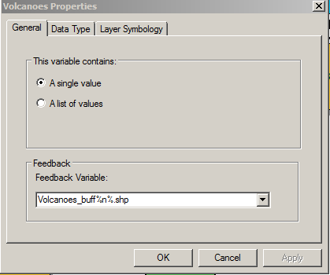

We add a separate process to the model for US cities

I used the Select Feature tool again for USA_cities.shp file to show where in highly populated cities lie to in relation to the volcanoes.

I got an output file called USA_cities_Select.shp file by using the USA_cities.shp file and PopulationAmt parameter.

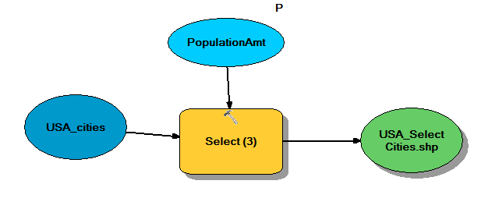

The Third parameter selected with default number greater than 300,000 population. Double-click the model in ArcCatalog to get this window. This parameter can be adjusted by the user.
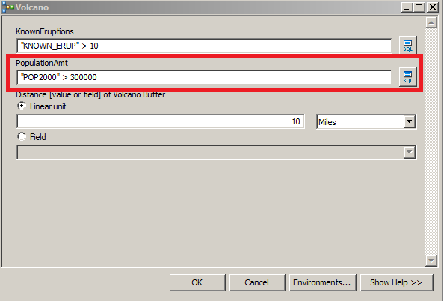

We add a Precondition to the Model

I made a Precondition listed below for the PopulationAmt parameter for the Select Feature tool (Select), Select Feature tool 2 (Select 2), and Buffer tool as my final step. (Shown below in top picture)

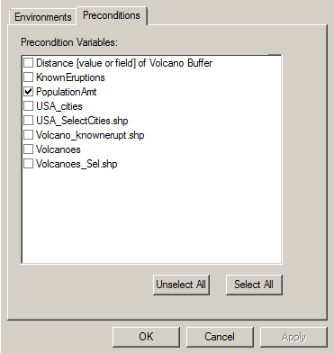
Dashed black lines are the Preconditions

Dashed blue lines are the “Feedback Variable”
The map below is what our model specified as an end result shown.
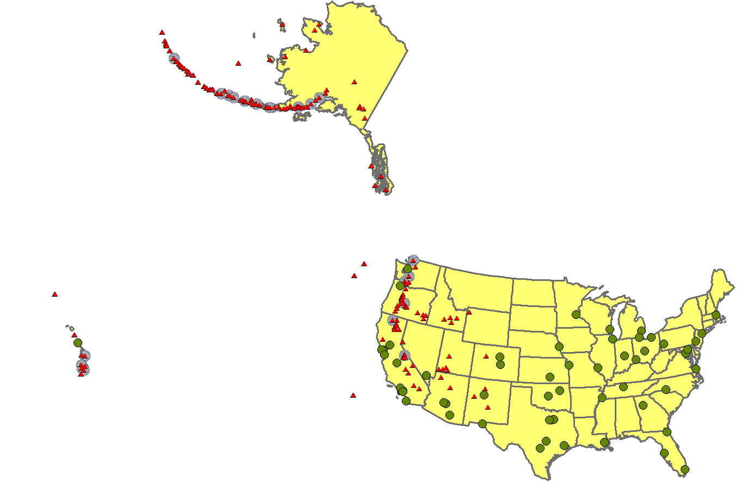
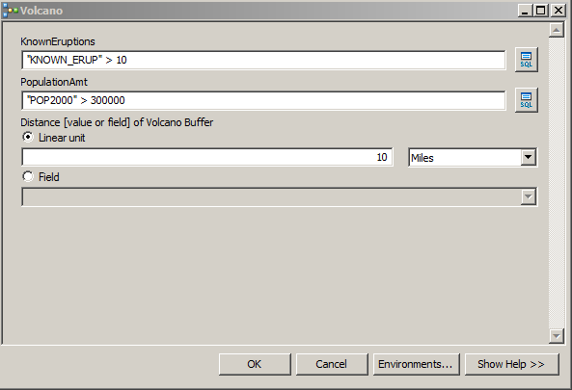
(These are the defaults for each of the parameters though the numbers can be changed to anyway the user specifies).

Picture of two volcanoes that erupted recently that made news in recent history. 